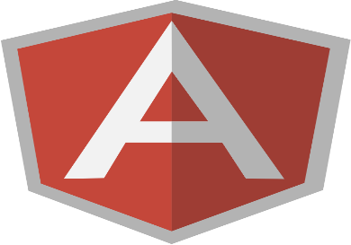Protractor Tutorial

Introduction

Protractor is an end to end and *automated testing* framework for AngularJS applications built on top of webDriverJS.

Protractor runs tests against your application running in a real browser, interacting with it as user world.

**Testing Vocabulary**

* End to End Testing
* Functional Testing
* Web integration Testing
* GUI Testing
* Acceptance Testing
* Customer Testing

**Protractor**

* Built on top of webDriverJS
* Add AngularJS integration
  + Waits for AngularJS to be bootstrapped.
  + Listen to AngularJS internals ($http...) to determine when to get to the next steps.
  + Provide 2 sets of API:
    - Wrapped WebDriverJS API
    - New API AngularJS specific (find by binding, repeaters...)
* Provide tools to help debugging
* Facilitator for setting up (download & launch) easily a Remote WebDriver and launching tests for Chrome, Firefox & IE.
* Sauce labs Integration.

## Why is testing so important?

*Testing is about gaining confidence that your code does what you think it should do*

## What’s the idea behind E2E testing?

* How would the users see my application?
* Is my backend communicating with my frontend?
* Can I release this code?
* It does **NOT** replace Unit Testing!

## The dark side of E2E testing

* It needs a specific running environment
* It's hard to write
* It's difficult to debug
* It's hard to keep the tests up-to-date

## Protractor is built on top of [WebDriverJS](https://code.google.com/p/selenium/wiki/WebDriverJs)

**Testing system** (NodeJS, Java, etc)

|

**Webdriver** (a.k.a. Selenium)

|

**Your AngularJS App**

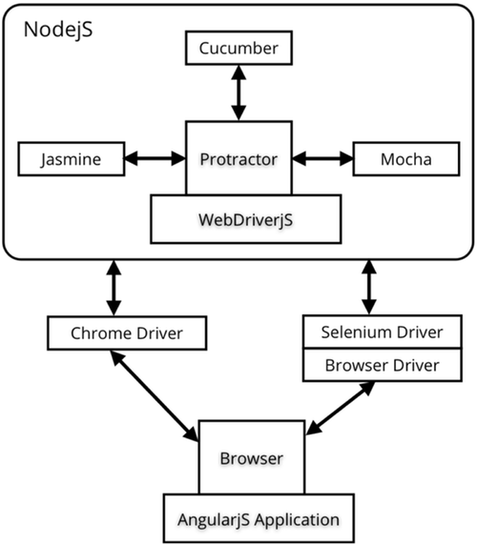

## **Prerequisites**

* Protractor is a [Node.js](http://nodejs.org/) program.
* To run, you will need to have Node.js installed.
* You will download Protractor package using [npm](https://www.npmjs.org/), which comes with Node.js.
* Check the version of Node.js you have by running node --version.
* It should be greater than v0.10.0.
* By default, Protractor uses the [Jasmine](http://jasmine.github.io/1.3/introduction.html) test framework for its testing interface.
* This tutorial assumes some familiarity with Jasmine.
* This tutorial will set up a test using a local standalone Selenium Server to control browsers.
* You will need to have the [Java Development Kit (JDK)](http://www.oracle.com/technetwork/java/javase/downloads/index.html) installed to run the standalone Selenium Server.
* Check this by running java -version from the command line

## **Setup**

Use npm to install Protractor globally with:

npm install -g protractor

This will install two command line tools, protractor and webdriver-manager.

Try running protractor –version to make sure it's working.

The webdriver-manager is a helper tool to easily get an instance of a Selenium Server running.

Use it to download the necessary binaries with:

webdriver-manager update

Now start up a server with:

webdriver-manager start

This will start up a Selenium Server and will output a bunch of info logs.

Your Protractor test will send requests to this server to control a local browser.

Leave this server running during your tests.

You can see information about the status of the server at http://localhost:4444/wd/hub.

## **Step 1 - write a test**

Open a new command line or terminal window and create a clean folder for testing.

Protractor needs two files to run, a **spec file** and a **configuration file**.

Let's start with a simple test that navigates to an example AngularJS application and checks its title.

We’ll use the Super Calculator application at <http://juliemr.github.io/protractor-demo/>.

Copy the following into spec.js:

// spec.js

describe('Protractor Demo App', function() {

it('should have a title', function() {

browser.get('http://juliemr.github.io/protractor-demo/');

expect(browser.getTitle()).toEqual('Super Calculator');

});

});

The describe and it syntax is from the Jasmine framework.

browser is a global created by Protractor, which is used for browser-level commands such as navigation with browser.get.

Now create the configuration file. Copy the following into conf.js:

// conf.js

exports.config = {

seleniumAddress: 'http://localhost:4444/wd/hub',

specs: ['spec.js']

}

This configuration tells Protractor where your test files (specs) are, and where to talk to your Selenium Server (seleniumAddress).

It will use the defaults for all other configuration. Chrome is the default browser.

Now run the test with

protractor conf.js

You should see a Chrome/firefox browser window open up and navigate to the Calculator, then close itself (this should be very fast!).

The test output should be 1 tests, 1 assertion, 0 failures.

Congratulations, you've run your first Protractor test!

## **Step 2 - interacting with elements**

Now let's modify the test to interact with elements on the page. Change spec.js to the following:

// spec.js

describe('Protractor Demo App', function() {

it('should add one and two', function() {

browser.get('http://juliemr.github.io/protractor-demo/');

element(by.model('first')).sendKeys(1);

element(by.model('second')).sendKeys(2);

element(by.id('gobutton')).click();

expect(element(by.binding('latest')).getText()).

toEqual('5'); // This is wrong!

});

});

This uses the globals element and by, which are also created by Protractor.

The element function is used for finding HTML elements on your webpage.

It returns an ElementFinder object, which can be used to interact with the element or get information from it.

In this test, we use sendKeys to type into <input>s, click to click a button, and getText to return the content of an element.

element takes one parameter, a Locator, which describes how to find the element.

The by object creates Locators. Here, we're using three types of Locators:

* by.model('first') to find the element with ng-model="first". If you inspect the Calculator page source, you will see this is <input type=text ng-model="first">.
* by.id('gobutton') to find the element with the given id. This finds <button id="gobutton">.
* by.binding('latest') to find the element bound to the variable latest. This finds the span containing{{latest}}

Run the tests with

protractor conf.js

You should see the page enter two numbers and wait for the result to be displayed.

Because the result is 3, not 5, our test fails. Fix the test and try running it again.

## **Step 3 - writing multiple scenarios**

Let's put these two tests together and clean them up a bit. Change spec.js to the following:

// spec.js

describe('Protractor Demo App', function() {

var firstNumber = element(by.model('first'));

var secondNumber = element(by.model('second'));

var goButton = element(by.id('gobutton'));

var latestResult = element(by.binding('latest'));

beforeEach(function() {

browser.get('http://juliemr.github.io/protractor-demo/');

});

it('should have a title', function() {

expect(browser.getTitle()).toEqual('Super Calculator');

});

it('should add one and two', function() {

firstNumber.sendKeys(1);

secondNumber.sendKeys(2);

goButton.click();

expect(latestResult.getText()).toEqual('3');

});

it('should add four and six', function() {

// Fill this in.

expect(latestResult.getText()).toEqual('10');

});

});

Here, we've pulled the navigation out into a beforeEach function which is run before every it block. We've also stored the ElementFinders for the first and second input in nice variables that can be reused. Fill out the second test using those variables, and run the tests again to ensure they pass.

## **Step 4 - changing the configuration**

Now that we've written some basic tests, let's take a look at the configuration file.

The configuration file lets you change things like which browsers are used and how to connect to the Selenium Server.

Let's change the browser. Change conf.js to the following:

// conf.js

exports.config = {

seleniumAddress: 'http://localhost:4444/wd/hub',

specs: ['spec.js'],

capabilities: {

browserName: 'firefox'

}

}

Try running the tests again.

You should see the tests running on Firefox instead of Chrome.

The capabilities object describes the browser to be tested against.

You can also run tests on more than one browser at once. Change conf.js to:

// conf.js

exports.config = {

seleniumAddress: 'http://localhost:4444/wd/hub',

specs: ['spec.js'],

multiCapabilities: [{

browserName: 'firefox'

}, {

browserName: 'chrome'

}]

}

Try running once again.

You should see the tests running on Chrome and Firefox simultaneously, and the results reported separately on the command line.

## **Step 5 - lists of elements**

Let's go back to the test files.

Feel free to change the configuration back to using only one browser.

Sometimes, you will want to deal with a list of multiple elements.

You can do this with element.all, which returns an ElementArrayFinder.

In our calculator application, every operation is logged in the history, which is implemented on the site as a table with ng-repeat.

Let's do a couple of operations, then test that they're in the history. Change spec.js to:

// spec.js

describe('Protractor Demo App', function() {

var firstNumber = element(by.model('first'));

var secondNumber = element(by.model('second'));

var goButton = element(by.id('gobutton'));

var latestResult = element(by.binding('latest'));

var history = element.all(by.repeater('result in memory'));

function add(a, b) {

firstNumber.sendKeys(a);

secondNumber.sendKeys(b);

goButton.click();

}

beforeEach(function() {

browser.get('http://juliemr.github.io/protractor-demo/');

});

it('should have a history', function() {

add(1, 2);

add(3, 4);

expect(history.count()).toEqual(2);

add(5, 6);

expect(history.count()).toEqual(0); // This is wrong!

});

});

We've done a couple things here - first, we created a helper function, add.

We've added the variable history. We use element.all with the by.repeater Locator to get an ElementArrayFinder. In our spec, we assert that the history has the expected length using the count method. Fix the test so that the second expectation passes.

ElementArrayFinder has many methods in addition to count.

Let's use last to get an ElementFinder that matches the last element found by the Locator.

Change the test to:

it('should have a history', function() {

add(1, 2);

add(3, 4);

expect(history.last().getText()).toContain('1 + 2');

expect(history.first().getText()).toContain('foo'); // This is wrong!

});

Since the Calculator reports the oldest result at the bottom, the oldest addition (1 + 2) be the last history entry.

We're using the toContain Jasmine matcher to assert that the element text contains "1 + 2".

The full element text will also contain the timestamp and the result.

Fix the test so that it correctly expects the first history entry to contain the text "3 + 4".

ElementArrayFinder also has methods each, map, filter, and reduce which are analogous to JavaScript Array methods.